**Angular Architecture:**

3 pages of text:

Static site:

1. What is a component?

A piece of display is a component.

In the display example there are 3 components:

1 – The menu

2 – The body for each page

3 – The copyright symbol

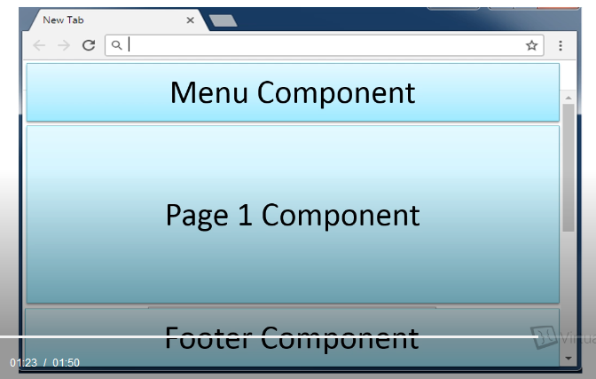

1. Index.html and styles.css

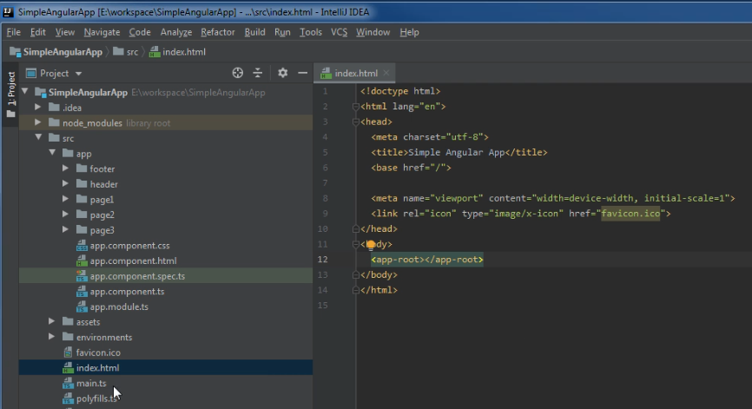

All pages get the index and styles pages

1. Component Selectors - special tags selector: app-root

<body>

<app-root></app-root>

</body>

Header.components

<app-header></app-header>

1. 4 component files per selector
2. Html - layout
3. Css - style
4. Typescript – class file – backing file for html
5. Typescript – spec file – unit testing

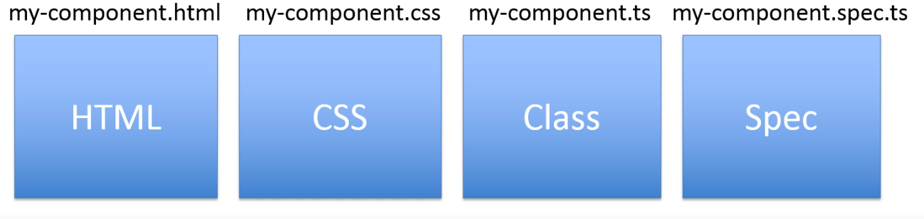

1. Page construction

Find the component with the matching selector

Decorator @Component

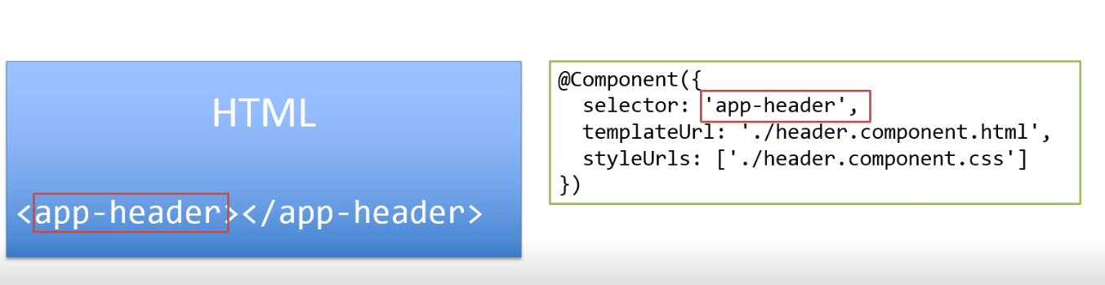

All selectors must be unique

1. Angular doesn’t assembly the HTML

Javascript files contain the compiled HTML

Using view source shows the javascript pages



These links contain the HTML files.

There is no history for the back button, the url never changes you are on the same page.